Wild Fun in California—Summer 2017

Codes: MMf

My name is Kelly and I’m seventeen. I was a cheerleader in middle school, but I didn’t make my high school cheerleading team. I live in a small town in Arkansas where everyone knows me. Therefore, I must be careful to maintain my nice girl reputation. That doesn’t mean I haven’t done a few things that might shock my neighbors and that my parents wouldn’t approve me doing, but I do need to be careful.

The following occurred early this summer when at age 17. I was visiting my aunt in California. As I was exploring the city and having fun, David and John, two young, good-looking, and sexy guys, took this picture of me.

David and John were both age 22. They had just graduated from college. They were from out of town for some school or training, and they were sharing a room in a nearby hotel.

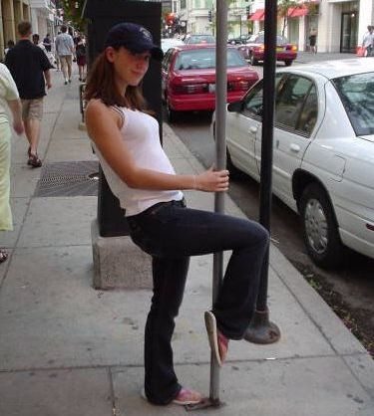
We started talking and I was flirting. They were very nice. They were charming, smart, educated, and good looking--the type of guys I am attracted to. We immediately clicked and I was delighted to have the attention of two sexy and good looking guys.

After we visited for a while, the guys invited me to go have pizza with them and of course I accepted. The following is a picture of David and me followed by a picture of John and me.

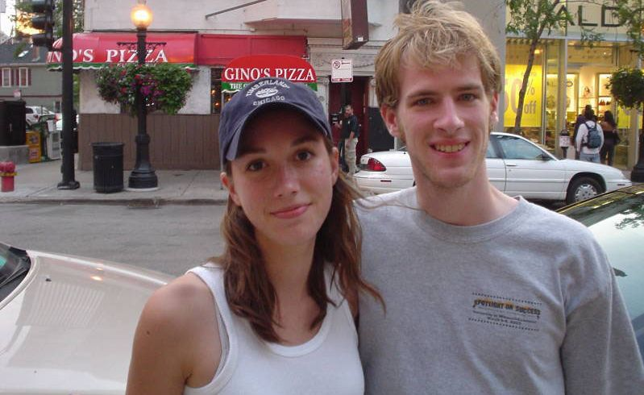

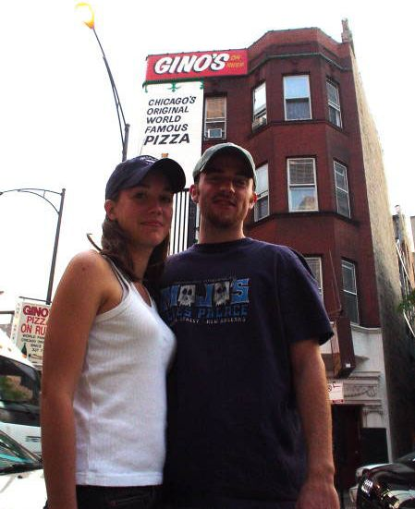

After having pizza, we went riding on a cable car. This is a picture of John and me on the cable car.

As you can tell I was having fun because I was thrilled to have the attention of both guys. Before going home for the night, the guys and I made a date to go swimming and hang out at the beach the next day.

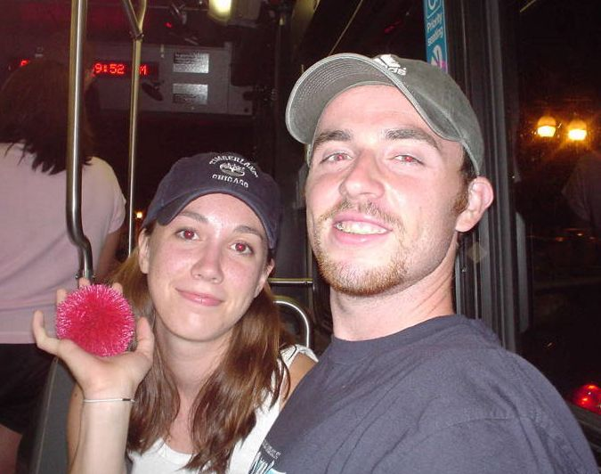

The guys picked me up a little after noon the next day. I had decided to wear my awesometastic Brazilian black bikini held on with four bowties. When we arrived at the beach, I decided to go beach exploring with the guys. David and John took quite a few photos of me and of course, being the exhibitionist that I am, I loved posing for the photos.

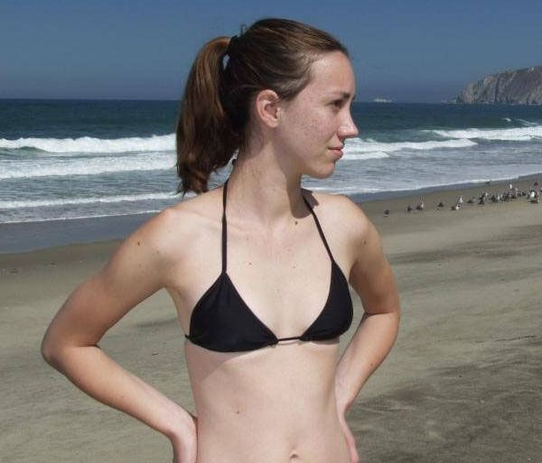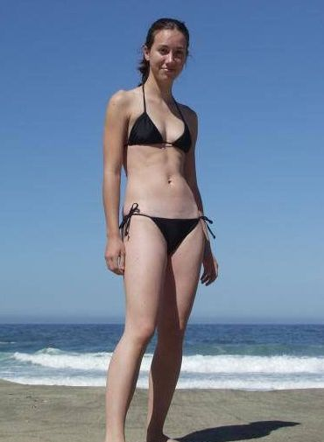

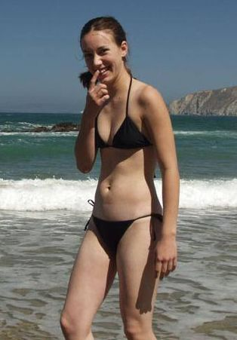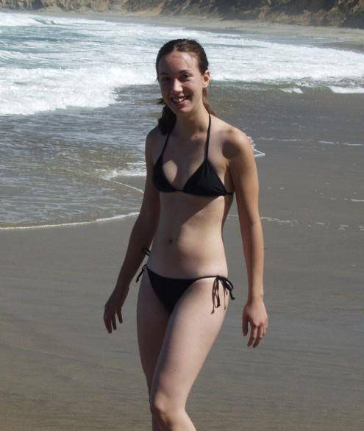

The second photo below on this page is me posing with John. Those are followed by more pictures of me on the next page.

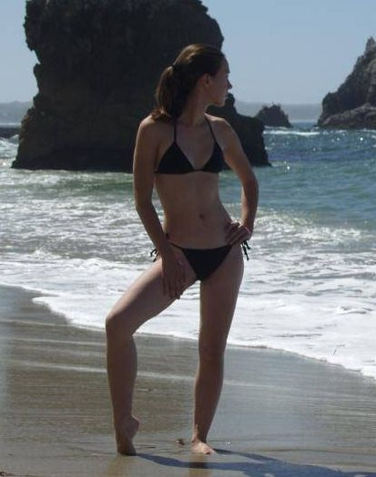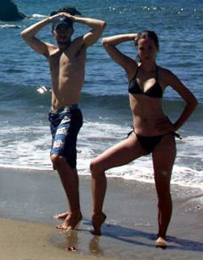

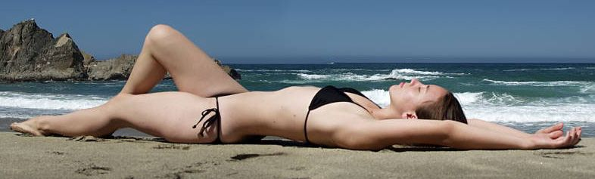

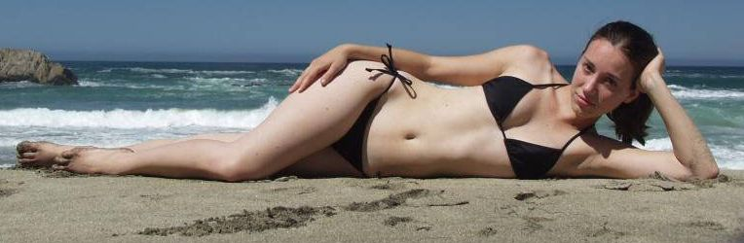

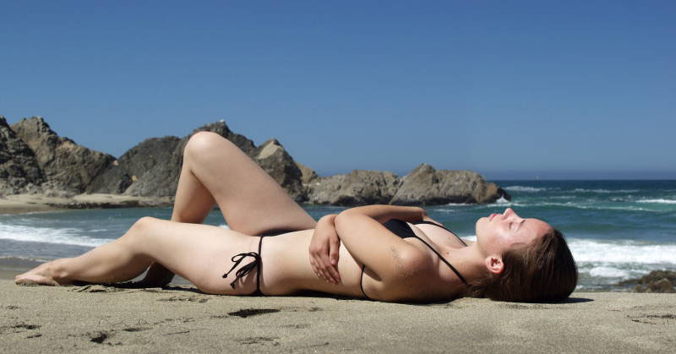

Before long I was doing some heavy flirting and the guys were making innuendoes. I didn't mind; I kind of liked it because I was enjoying the attention from two handsome guys. We went to get something to eat and when we returned the guys resumed taking photos of me. In the photo below on the right you can see where John wrote sexy in the sand on my tummy.

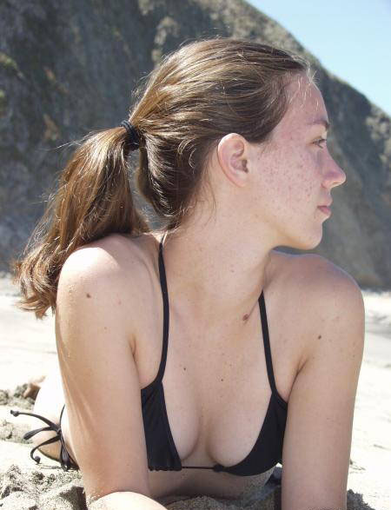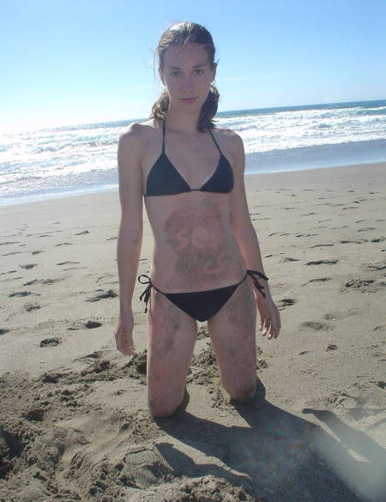

I think the guys especially liked the next pose of me making a sand angle. It is almost obscene, but I just having fun and I didn’t realize it at the time. John asked if he could pull the bowties to my bikini. I was enjoying the attention, so I laughed and replied, Well, maybe later.

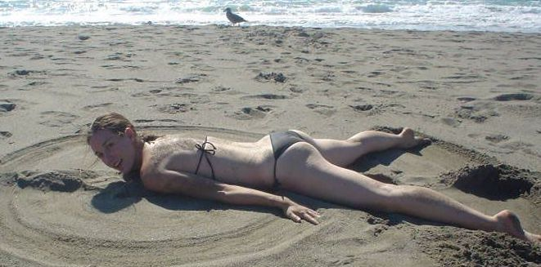

I went wading in the water and attempted to go swimming. However, the ocean was too cold for swimming so the guys invited me to go swimming in their hotel swimming pool and I accepted. The guys drove me to their hotel which, with the traffic, was about a thirty minute drive. As you can see it was really a nice swimming pool located on the top the hotel.

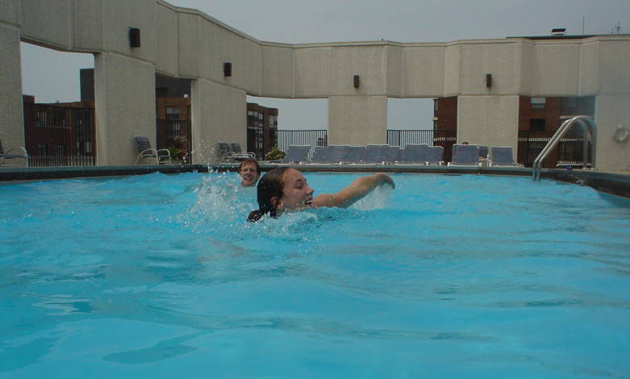

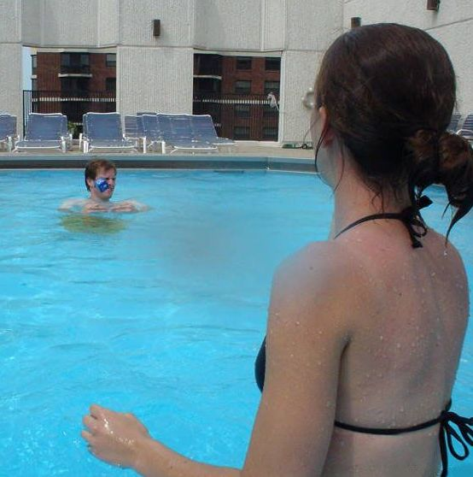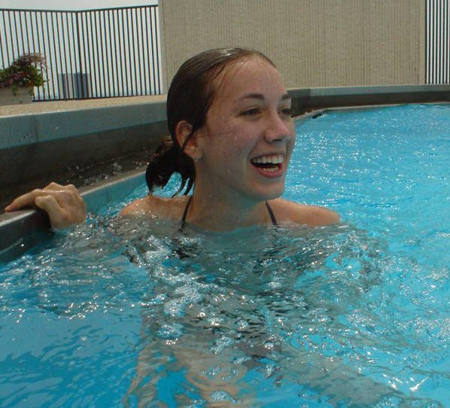

As you can tell from the photos, I was having fun swimming and flirting with the guys. After swimming for a while, John suggested we go have strawberry daiquiris in their room. David said it was one of the top floors and had a really nice view of the city. I decided that might be fun and besides I had a strawberry before and I really liked it so naturally I agreed. Of course, I would have anyway.

I do have a wild streak. I have done things such as skinny dipping, oral sex, and giving a guys hand jobs like in this picture. There were couple of others there not shown in this picture and we started out by playing strip poker. He squirted so quick and unexpectedly that I couldn’t dodge. So he squirted in my face.



However, until then I only had sexual intercourse with one guy, a high school boyfriend that fucked me after the prom, so having sex wasn’t on my mind. At least, if it was on my mind, it was in the back of mind. Not that it mattered; but, unlike Arkansas where the age in consent is 16, in California, I wasn't legal, having had my seventeenth birthday only six months earlier.

In any event, I didn't object to going to their room because they were both very nice and I knew I was in control. Besides, I wanted to see the view of the city from up high and I was having fun flirting with the guys.

This photo is taken in their hotel room. While John is making the strawberry daiquiris, I’m smiling and flirting with David.
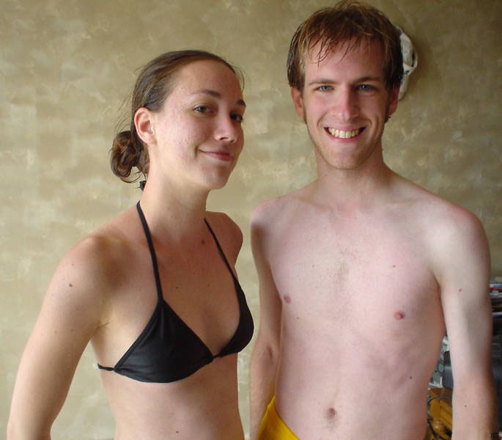

John gave me a strawberry daiquiri and asked me to dance.

For the next hour or so, I would sip on a daiquiri and dance with the guys. They started kissing on my neck and before long our dancing begin to get rather sexy.

When we danced close, I could feel through his shorts that John was getting turned on. I was feeling naughty so when our bodies were pressed together, like in this photo, I would bounce up and down and rotate my hips to rub my tummy against his cock. I’m a tease (maybe a cock tease) so I was thrilled to feel him getting excited. It wasn’t my intent; however, if I had made him cum in his shorts and realized it, I would have been so thrilled.
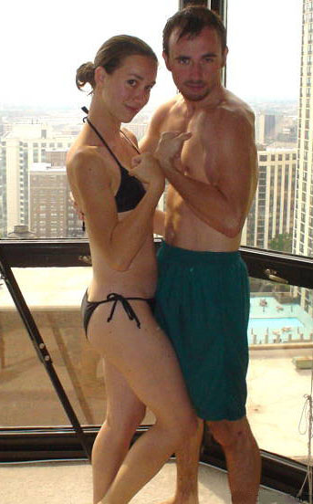

The guys would make little innuendoes but they were not aggressive and I knew I was in control. Therefore, I didn’t do anything to discourage them and perhaps even encouraged them because they were getting bolder. In any event, I was having fun and I liked their attention so I didn’t mind.

John squeezed my bottom, pulling my body tight up against him and kissed me so I kissed him back.

I’m sure David saw John and me kiss because the next time we danced, David gave me a lengthy kiss. It was nice. Between the daiquiris, the kisses, and feeling the guys getting sexually excited, I was getting turned on.

I decided to take a break from dancing and, while I was sipping on my daiquiri, John was giving me a little shoulder and neck massage. I leaned into him and said, That nice. John told me he gives good back massages and asked if he could give me one. After I said, Okay, he pulled the bedspread down and directed me to lay face down on a pillow. While John was giving me a back massage David started massaging my feet. It all felt good and with the combination of the alcohol and massages I was relaxed and becoming sexually excited.

David started sucking on my toes and that was turning me on. Next the guys started giving me an all over body massage with coco butter. At first they were being proper or perhaps they were just being cautious; however, when I didn't protest, they started getting bolder and would work their fingers a little ways under my bikini. They were applying kisses all over my face, lips, neck, and body. And especially, the kisses David was giving me on my inner thighs were getting me extremely sexually excited.

John asked if he could pull my bowties and when I didn’t answer immediately he asked, Just the top?

Well, alright, I replied so John pulled the bowties to my top and when the guys rolled me over, I was topless giving them access to my titties. John started sucking on my titties which only intensified my sexual excitement.

David asked, Can I pull your bowties too?

I replied, You guys…you want me naked. I don’t remember David’s exact words but he let me know that is what they wanted. I was feeling bold so I said, Well okay, if you want to. At that point, I was too sexually excited and too turned on to refuse. Also, being the exhibitionist that I am, I kind of like it when I can find an appropriate excuse, without appearing slutty, to let guys see me showing a lot of skin or even see me naked.

Normally I probably would not have allowed it to go that far. However, I was in the middle of my period and probably ovulating or close to it and that is when I am the horniest.

David started licking my pussy. I believe he was doing the alphabet on my pussy with his tongue and it was driving me wild. By then I knew I wasn't going to protest if I got fucked because I was so turned on that I wanted to be fucked; I needed a hard cock in my pussy.

I remember I started moaning and from the sounds I was making, I was practically begging to be fucked. To encourage David to climb on top of me fuck me, I believe I was pulling on his hair and/or tugging on him. In any event, David started working his way up my body; kissing my tummy and my titties. For just a couple of seconds I felt the head of his cock pressing on the entrance of my pussy but I was wet and well lubricated and a moment later I felt him thrust his hard cock deep into my pussy. He started fucking me hard and fast. I remember lifting my legs and wrapping them around him as if I was trying to pull him in into me deeper.

He only fucked me for a couple of minutes and I could tell he was cumming. I hadn't cum yet and I wanted to be fucked more. Fortunately as soon as he withdrew, John directed me to turn over. He then fucked me doggy-style giving me a good orgasm I was moaning and then aaaaaaa-oooo-iiii-eeeeeeeeeee.

I lay in bed with a guy on each sides of me. They were caressing me and sometimes kissing me or sucking on my titties. I was in heaven. A little while later, John told me he was going to give me a shower. We got into the shower and he soaped me down well including my pussy before showering me off. All the time his cock was erect. I decided to suck on it and did for a little, but he said he wanted to fuck me. We were having some difficult in the shower until I stood with my feet on both sides of the shower-bathtub with my back against the wall. I had to bend my knees but then my pussy was the perfect height for John to fuck me standing up. John stood between my legs and fucked me really good. He made me cum again. It felt wonderful.

That is a position I can recommend. With my feet on both sides of the shower-tub my legs were already spread but I spread them more when I bent my knees.

John soaped me down again and we stayed in the shower for another five or ten minutes before we got out and dried off. The first bed already had wet spots so we got into the other bed. Then David climbed on top and fucked me again. The guys kept taking turns fucking me. While I was being fucked my awesometastic Brazilian bikini hung on the bathroom wall.

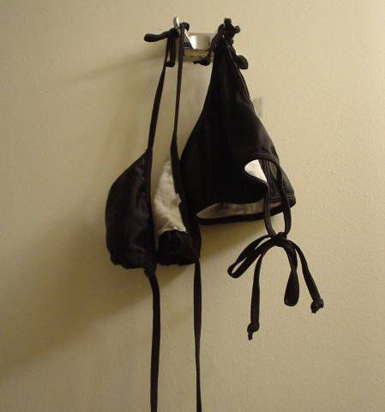

I wasn’t really counting; however, I believe, I got fucked seven times that evening and I know I had six or more orgasms. That was the most, the sexist, and best evening of fucking I ever had. I believe the guys would have fucked me more; but, because I was visiting my aunt, I didn't feel I should stay out too much later. So, with cum dripping from my pussy, I took another shower and the guys took me home. The guys asked me to come back and I might have if I had visited my aunt longer and if I was on the pill.

I was in the middle of my monthly cycle and probably ovulating. Therefore, since I wasn’t on the pill, the next morning I purchased Plan B, an over-the-counter morning-after-pill. The morning-after pill is 95 percent effective if taken within the first twenty-four hours. Normally I would not have had sex, let alone unprotected sex. That was not in my plans. However, I was so sexually excited that I didn’t think, and likely I didn’t even care, about risks until afterwards.

The threesome in California was only my second one-night-stand, the first being after the prom a couple of weeks earlier. That is, if fucking a boyfriend, one time is a one-night-stand. However, if the situation had been different, I would have loved for it to have lasted a lot longer. Finding two guys to have threesomes with is something I believe I could fall in love with. I liked it the way it worked out; that is, the guys taking turns. I don’t believe I would have been as interested in doing both guys at once. Then again, sucking a cock while I’m being fucked doggy style might be a lot of fun. That one night stand is an experience I have good memories of. It was such a special occasion, I wrote it my dairy and most of the story is from my diary.

Next year I may spend the summer with my aunt in California. I’m sure I can meet lots of guys in California. Also being so far from home should allow me the freedom to not be so concerned about my reputation. I’m thinking that I could go to the marina, leisurely stroll in my bikini, and get invitations to go sailing by sexy guys with very large sail boats. The kind of guys that would take me places I have never been and cannot afford. And, if they are good looking and sexy, I won’t mind if there is more than one guy on the large sail boat because once we have sailed ten, twenty, or more miles out in ocean and too far to see any land, I intend to get naked and be fucked on the deck with the sun shining down on us. Whether that is only one guy that fucks me or even if there are more guys on the sailboat and I’m gangbanged, I am going to love it and that can be the start of a torrid short summer romance. What happens in California will stay in California and I expect to return with very good memories.

Send comments to smjle4me@windstream.net

