Naughty Kelley

Story Codes: mf, bf, oral bg and mg.

Characters
Kelley f, age 17 first person, I me, etc.
Amy f, age 12
Brooke f, age 12
Bryan m, age 13
Calvin m, age 12

Last month Amy, Brooke, and I, agreed that we would rent a boat and go on an outing at the lake. Amy and Brooke would invite a couple of boys and they would like to a boy have sex with me. It is a big lake, surrounded by woods, and there are lots of little coves where we can swim and have privacy.

Before leaving for the lake, I talked to the girls about what would be allowed and what they were willing to do. Amy said she was willing to get naked, let a boy kiss her pussy, and touch, and kiss a boys cock. She was also willing to milk a boy’s cock like they did to Jason last month. Brooke said she would the same plus she would willing to French kiss a boys cock.

“I think we will have a lot of fun; but, even if it is something you said you would do, if you decided you don’t want to do it or anything else but you don’t want to say ‘no’, just touch your earlobe and I won’t allow it.”

“So it’s agreed, you girls will invite a couple of boys and I will drive you to the lake, rent a boat, swim, and have fun. I’ll bring a cooler with soft drinks and something to snack on. And, we will all get naked and go skinny dipping. Then maybe I’ll let one of the boy’s have sex with me. Would you like to see that?" I asked.

"I want to see,” a grinning Brooke said. "Me too," replied Amy.
“Okay, bring your swim suits. You can cover them with a wrap or wear them under your clothes and I’ll pick you about 9 a.m. Saturday.

I wore my ‘fuck me’ bikini that in public I would cover with a pull-up skirt or a wrap for my bikini bottoms.


Amy wore a purple top and jeans over her bikini and Brooke covered her bikini with a pullover mini-dress.
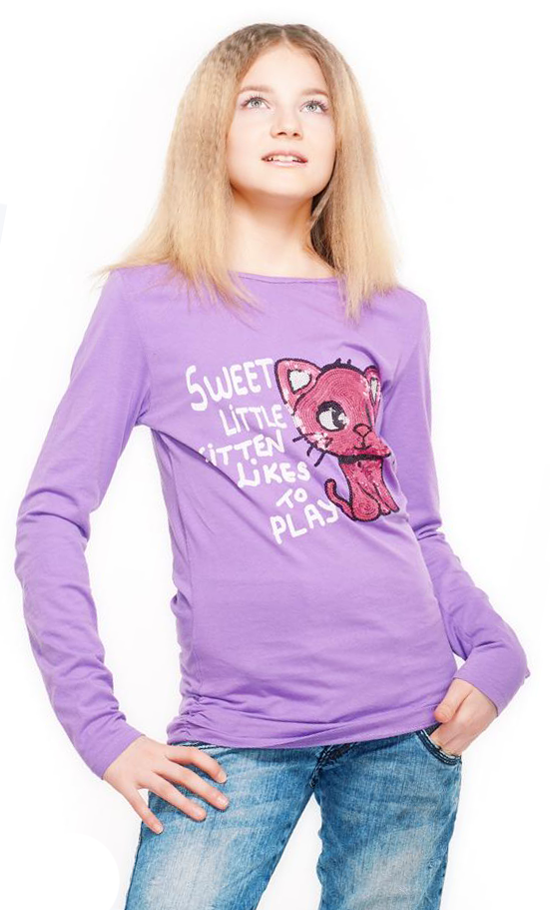

I picked up the girls and Brian and Calvin, the two boys they invited and drove to the lake. I rented a boat with a motor and we rode for the next hour having fun and looking for a perfect secluded place. We found a cove, surrounded by woods with big trees and little underbrush and no nearby road.

While in the boat, I said, “We should just be wearing our bathing suits.” I removed my wrap and Brooke quickly followed by pulling her mini-dress over her. Then Amy removed her top and jeans. The boys were already topless and only needed to remove their jeans.

Seeing my ‘fuck me’ bikini, Calvin, with everyone listening, said, “I’ll fuck you.”

“Are you sure,” I replied.

“Yesss,” he quickly replied.

“If I say ‘yes’ are going to change your mind and back out?”

“No way! I want to fuck you”

“Okay! Maybe later.”

“I want to fuck you too,” Brian said.

“Girls, is it okay if Bryan and Calvin both fuck me?”

“Yes, of course,” Brooke said excitedly and Amy nodded and grinned.

“I’ve never been fucked by two guys but I guess there is always a first time. Well then, okay! Maybe after we go swimming and have something to eat.” This is turning out to be easier than I expected. Maybe I will get a couple of virgin’s cherries. Getting a guy’s cherry is especially appealing and exciting. I know that most boys and girls can have orgasms at a very early age. However, most boys first ejaculate between the ages of 11 and 14. And, since Calvin will be 13 in two months it is likely that one probably both would. I noticed that although Brian is a little older, Calvin more assertive.

After arriving at the cove, we moved the blankets and cooler containing soft drinks and sandwiches about fifty feet from the water then went wadding, swimming, and playing in the water for thirty minutes or so until it was almost noon and time to eat. After lunch, I suggested skinny dipping and the girls and both boys were enthused and excited about that.

I said, “Even though this is a secluded area, it is still possible someone walk by and see us. And, since we don’t want some busybody harassing us, if we see someone, grab you clothes and swimsuits, and Calvin and Brian, grab the cooler and blankets and lets all dash to the boat and go somewhere else. I don’t think anyone will come by, but just in case let’s be prepared.”

We played in the water naked for a few minutes with some light sexy touching. Then I said, “Let’s play truth and dare.” When we were all seated on the blankets, I said, “Since we are naked, dares will be French kissing or kissing or licking any bare area of one or more of the opposite sex and penalties will be the same. We will play clockwise starting with Amy.”

I though Amy would ask Brian or Calvin but instead she asked me, “Truth or dare?”

“Truth.”

“Tell how many guys you have fucked, how old were they, and when did you start?”

“Four guys. The first time was with a nineteen year old college student when I was fourteen. The other three guys were fifteen to eighteen.”

Next was Brian and he dared Amy to French kiss Calvin for thirty seconds.

Brooke was next and asked Calvin if he was a virgin. Calvin was embarrassed but admitted that he is.”

I chose truth again and Calvin asked me, “Can I fuck you.”

“In a little while and definitely before we leave to go home.” I think his already hard cock, jumped at my answer.

“Brooke, truth or dare,” I asked. When she chose dare, I wanted to enhance the game so I said, “I dared you to French kiss Brian’s cock for ten seconds.”

Amy asked Brian if he was a virgin. He is.

Brian asked Brooke how far she had gone with a boy. “Just a French kiss, not counting today,” she replied.

I guess Brooke wanted to pay me back because she dared me French kiss Calvin’s cock for thirty seconds. I could taste his precum so I knew that as likely as not I could make him squirt in my mouth in thirty seconds. However, I didn’t want him to cum before he fucked me so I just kept in my mouth and barely licked it.

Calvin asked Amy how far she had gone with a boy. “Just a kiss,” she answered.

Then it was my turn again and decided it was time to get very serious. I said, “I have a double dare. Brian, Calvin I want you to each choose Amy or Brooke, French kiss her, then suck on titties for thirty second, and then lick her pussy and try and give her an orgasm. Lick up and down, and sideways, and lick the alphabet. If you give her an orgasm, you get to fuck me.” I knew that, with the internet, curious boys would know how.

“Amy, Brooke,” I said. “Lie down on the blankets, spread your legs and enjoy.”

Calvin gave Brooke and orgasm first but Amy was moaning and I could tell she was close so I waited a little longer. Then I took Calvin’s hand, hugged him close, rubbed my belly into his cock while French kissing him. Then I lay down on the blankets, spread my legs, and pulled him on top. I felt his hard cock poking on my pussy and then, since I was already dripping wet, it easily slipped all the way and he started fucking me as I wrapped my legs around his legs and grabbed his butt with my hands to pull him in even deeper. Like most almost thirteen year old boys, he was full of energy and was really pounding my pussy fast and furious.

It didn’t take him long to cum; only long enough for me go have a mini-orgasm. I grabbed Brian’s hand and said, “You can fuck me in the water and Brook and Amy you can come and watch. And Calvin you can come too. We wadded out to waist deep water. The water was clear so by standing close, Amy and Brooke could see.

Brian and I were face to face and I adjusted my position to assist him in putting his hard cock into my pussy. I said, “Yes Yessss, Your cock feels so good.” I started moaning and as he was giving me an orgasm, I said, “Yess, yess, yess; oh yessss ahhhhhhh oh yess.”

It was only mid afternoon so we lay on the blankets and talked; occasionally touching little. After about an hour, when I though the boys would have sufficiently recovered, I placed Calvin hand on my titty and lightly grazed Brian’s cock with my fingertips.

Immediately their cocks got hard. Knowing the water washed off any sex residue I said, “Girls it looks like Calvin and Brian’s cocks need more attention. Would you like to French kiss their cock and try and make them cum? It will be good experience for when you start dating a lot and want to please your boyfriend without fucking him.”

“Hmmmmmm! I will,” Brooke replied.

Amy though for a moment and surprised me by saying, “I will too.”

“Okay do just like taught you last month with your thumb. If you can make him cum, just swallow. It may look like a lot but it only a half to a teaspoon at the most. It doesn’t taste bad and it has hormones that are good for you. The winner, whoever makes the guy cum first gets a $30 gift certificate at Aeropostale.

It was fun watching how enthusiastic the girls were and the boys loved it. Amy won by a few seconds so I said, “Amy won, but it was close so, I giving you both a $30 gift certificate.” Just the same, Amy was so pleased with herself that she won.

“This has been a really fun and exciting day, but I think it is time for us to get dressed and head back home. And girls, early next week I will give you your gift certificates.”

On the way home, I told the boys, “Brian, Calvin! I have never been fucked by two guys before, but my God I loved it. Maybe in week or two, we will do again. Would you like that?”

“Yes! Yes!” They both said enthusiastically.

Send comments to smjle4me@windstream.net

